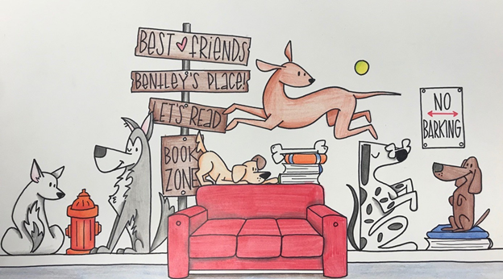

Sit Stay Read Camp

Bentley’s Place

707 N State Street

Greenfield, IN 46140 317-604-7309

**Formed can be mailed to the address above or emailed to bentleysbuddiesandfriends@email.com**

*Parent Permission Form*

Participants Name: ____________________________________________________________________

Street Address: _______________________________________________________________________

City, State, Zip: ________________________________________________________________________

Birthdate:­­­­­­­­­­­­­­­­­­­­­­­­_____________________________________________________________________________

Phone Number: ________________________________________________________________________

Email or Text Number: __________________________________________________________________

I give my permission for my child (named above) to attend____________________________

with Bentley’s Buddies and Friends on _________________________________________

I understand that my child will be supervised by BBF staff during this event. I hereby release the sponsoring organization and all its members from any liability or claims as well as damages or injuries which may occur at this event.

Parents/Guardian Signature: ____________________________________________

*Emergency Contact Information*

Emergency Contact: __________________________________________________

Relation to child: _____________________________________________________

Phone: _____________________________________________________________

Allergies: ____________________________________________________________

Child may be released to the following person with ID: ________________________________________

Child may be photographed for the website, paper or social media: Yes: ____ No: ___